Unit Time Management
Speaker: Tom Vinciguerra, Professional Consultant, former Chemical Engineer
Marie Argo, Middle School Math teacher, Oak Hills School District
Meredith Stoller, Middle School Science teacher, Oak Hills School District
Date: Thursday, July 21, 2016
Time: 9-11 AM
Venue: University of Cincinnati, Zimmer Hall, Room 414

Prepared by:
Samuel Mizener, Kings High School, Kings Mills, Ohio
RET Participant for Project #4: “Cyberspace: Attack & Defense”

For 33 years, Tom Vinciguerra has worked in numerous engineering technical and operational capacities at various pharmaceutical companies. His last work experiences include Director of Operations at Patheon Pharmaceuticals when he retired to professional consulting. Tom received a degree in BS Chemical Engineering from UC in 1976 and started his professional career with his coop company, Merrell Dow Pharmaceuticals. His professional areas of expertise include operations management, strategic planning, engineering, training and career development. Over his career, Tom has held multiple leadership roles as supervisor, manager and director in manufacturing, packaging, engineering, facilities, environmental, health and safety areas. Tom is very active in UC Alumni Association and was President of UC CEAS Alumni Association Board of Directors for last 6 years. In 2014, Tom was recognized for service to the UC Alumni Association for development of UC Alumni Strategic Plan. Tom is a proud father of 2 chemical engineers, his daughters.
For the last 2 years, Meredith Stoller has taught 8th Grade Integrated Science in the Oak Hills Local School District. In addition, she is an advisor for the National Junior Honor Society and You Be the Chemist competition at Rapid Run Middle School. She received a degree in Middle Childhood Education from the University of Cincinnati in 2014. Her area of expertise includes Natural Sciences and Language Arts grades 4-9. This is her second year in the CEEMS Program and she is working on her Masters in Curriculum and Instruction at the University of Cincinnati.
For the last 3 years, Marie Argo has taught 8th Grade Math and 8th Grade Honors Algebra in the Oak Hills Local School District. In addition, she coaches soccer, basketball, track, and runs the Rapid Run Middle School Math Club. Marie received a degree in AYA Integrated Mathematics and Mathematics & Statistics from Miami University in 2013. This is her second year in the CEEMS Program and she is working on her Masters in Curriculum and Instruction at UC.

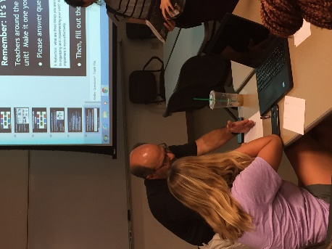

Figure 1: Tom Vinciguerra gives CEEMS teacher advice on implementing unit.

The session started with Mr. Tom Vinciguerra giving a lecture on the importance of the Engineering Design Process when it comes to student learning and also to teacher preparation as well. He mentioned that teachers use the EDP every year as they continually make lessons better and more refined. He also compared the EDP to the CEEMS program and how communication plays an important role when developing unit templates. Tom has several decades of experience working in the engineering industry and was adamant that students must learn communication skills when working with groups of their peers. A teacher asked, “What should we do when a parent complains that their son or daughters grade in class is partly determined by the other (less motivated) students in their group?” Tom answered succinctly that although there are ways you can encourage the parent and make sure their students grade is not impacted by a lack of another student, it is also important to reiterate the importance of group work. Tom made it clear that there is not a job in the work force that does not require teamwork.

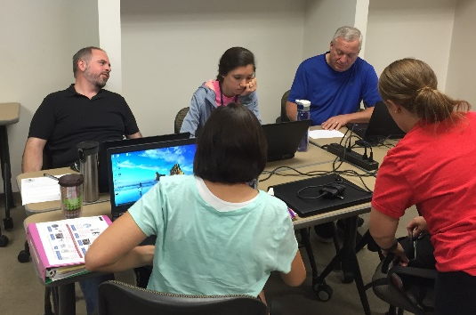
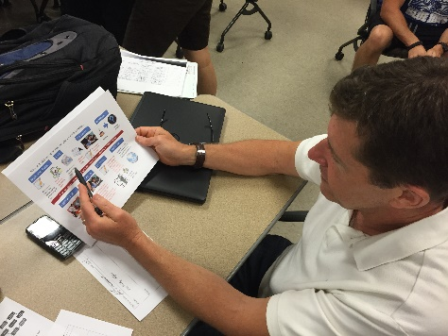

Figure 3: RET teachers work together to collaborate on implementing units while considering time constraints.
Figure 2: RET teacher reviews time outline for his unit on Cryptography.

Marie and Meredith took over the seminar and led the discussion on time management and how to appropriately prepare for your unit. Meredith made a very good point in that when there is less time than desired, decide what your goal is for students and make sure they get the time to achieve that goal. There are many things that may be worth sacrificing in order to end the unit on time, however, meeting essential goals is worth going over a day or two. Marie shared her personal experience with students who ask for more time on a project. She always thinks to herself, “Will more time give them a better product and help develop their understanding of the goals?” That point is critical in her response.
Tom, Marie, and Meredith outlined the top ten takeaway points they wanted everyone to understand before the end of the seminar. They are listed below:
- Establish end-date and stick to it
- Create team roles and reinforce them everyday
- Organize teams using folder and EDP WS
- Update coaches and Fellows with changes
- Try challenges/activities ahead of time
- Focus on hook, brainstorming, and essential questions
- Stress is okay - stick to your guns
- Outside source as Judges
- Don’t be afraid to make small changes within classes
- Work on post-unit requirements ASAP

